Benchmarking of distribution companies
Nebojša Despotović and AcaVučković

Abstract - The Energy Agency of the Republic of Serbia determines the methodology by which the maximum allowed revenue of distribution companies is defined. The Maximum allowed revenue represents the level of revenue which provides the company with a normal business activity within the regulatory period. Within the next few years, the Agency will developed methods which will introduce incentives for efficient improvement within the pricing models. These methods are based on the performances of each individual distribution company. These performances are determined by performing benchmarking techniques. The theoretical approaches for different benchmarking techniques and comparative results on a simple sample are presented in the paper. These results will be given by the application of different benchmarking techniques. The effects of applying the given benchmarking results through the assignation of individual incentive factors on Maximum allowed revenue to the companies are also shown.

Index Terms—benchmarking, efficiency improvement

INTRODUCTION
Benchmarking represents the relative performance of a certain company in regard to the best (reference) performance from a given sample. In the electricity distribution sector, benchmarking identifies the most efficient companies (determination of efficiency level) and measures the relative inefficiency of less efficient companies. This paper describes different techniques in theory. The comparative results are presented on a sample that consists of some Serbian and ERRA member distribution companies.
Based on responsibilities stipulated by the Energy Law, the Energy Agency of the Republic of Serbia specifies the methodology by which the maximum allowed revenue of the energy entities performing the activity of energy distribution is defined. The maximum allowed revenue represents the level of revenue which the energy entity can earn within the regulatory period, and which provides the company with a normal business performance. The maximum allowed revenue is determined based on the selected methodology. The methodology using the method of regulation „cost plus“ is in force at the moment. This methodology determines the maximum allowed revenue within the regulatory period, i.e. the price which enables a return on justified operating costs as well as a return on assets employed. The basic goal of this method is to identify and guarantee a certain profit. On the other hand, with the development of regulatory practice, a group of methods has been developed. These methods are based on the performance of each individual distribution company. Performances are determined by applying benchmarking techniques. These methods try to introduce incentives for efficiency improvements in the pricing models. These methods are expected to apply in Serbia within the next few years.
General formula for the introduction of incentives to eliminate inefficiency would be:
(1)
By this formula, approved revenue (or price) for the distribution company in year t (P_{t}) is equal to the income from the previous year (Pt-1) increased by the planned inflation (CPI) and less the incentive factor (X) which is determined on the basis of results obtained by benchmarking. The main goal of this method is to improve the operational efficiency of enterprises, which results in lower cost of distribution services. On the other hand, it is necessary to simultaneously take into account the maintenance and improvement of the quality of customer services, as well as the possibility of companies to cover their costs and make some profit.

Benchmarking
Efficiency benchmarking is a relative measure of the results of a subject in relation to the reference, the best result from the observed sample. Benchmarking identifies the most efficient companies in the sector (in the sample), determines the efficiency frontier (reference value) and measures the relative inefficiency of other companies against the referent value. Different benchmarking techniques are presented in Figure 1.

Fig. 1. Benchmarking techniques

Depending on the number of companies that are compared, the type and quality of input data, output indicators dimensionality and the way of obtaining the output, there are two main groups of benchmarking methods - partial, which are indicative methods because of their simplicity, and the total methods which require a larger sample for the analysis and greater accuracy of data available.

Partial methods
Uni-dimensional indicators are calculated by way of partial benchmarking methods. With regard to distribution companies, these are for instance: distributed energy per employee, number of customers per OPEX, distributed energy per OPEX etc. Comparing these parameters for different companies can provide valuable and indicative information based on which any company can improve its business characteristics. Such measures appear in annual reports of companies and are commonly used by market analysts because they are easy to calculate and interpret. However, the lack of such calculated indicators is that they are not able to establish, in a systematic way, relationships between different input and output factors characteristic for the distribution business. Thus, in the observed sample, a firm that performs well on one measure may do badly on another, while one firm may do reasonably well on all measures, but not be the most efficient on any. This problem can be solved by determining weighting factors for each observed indicator, whereby the main problem remains how to estimate the relative importance of each indicator?
The main disadvantage of using this method is that it doesn’t provide a unique approach to both selecting the observed indicators and determining the weights in the overall result. In this simple example in Table 1, combining only two indicators and reducing them to one synthetic indicator can result in completely opposite conclusions depending on which of the different weights was used. In the first case, the company A shows much better performance than the company B, in the second case, there is a slight difference, and in the last case, the company B shows better performance.

Table 1 – Example of application of partial benchmarking methods

Statistical indexes
Statistical indexes belong to the group of benchmarking index methods which are used to determine one aggregated indicator of the overall rate of productivity growth at the level of the whole industry or sector which is analyzed. In practice, the most commonly used is the so called Tornqvist total factor productivity index, which is the ratio of the weighted averages of all output factors (usually weighted in relation to the share in the total income), and weighted averages of all input factors (usually weighted in relation to the share in the total costs). The medium term growth rate of this index can be used as an indicator based on which incentives can be set and introduced into the price models to improve business efficiencies of companies. The main disadvantage of this method is that it does not take into account the differences between companies and thus introduces an equal value of efficiency (X factor) for all companies regardless of the actual state of their relative (in) efficiency. As a consequence of applying this method could be a situation that extremely inefficient companies would be able to easily meet and outperform any demands set by this efficiency measure and thus be awarded in the form of extra profit, while on the other hand, efficient companies with little scope for efficiency improvements and cost reduction would probably be penalized. Also, it is very difficult to determine Tornqvist total factor productivity index at the level of any sector, when it is necessary to have statistical data of high quality, which is, as a rule, not the case in practice.

Ordinary least squares (OLS) and corrected ordinary least squares (COLS)
Method of ordinary least squares is a statistical method of regression analysis based on the analysis of real business results. Any company from the observed sample on the diagram corresponds to one point (empirical point) whose position is determined on the basis of input and output data of the companies. The basic idea of this method is to determine the reference line among all the possible lines given in the diagram, which will be as close as possible to the empirical points, comparing with all possible lines in the diagram:
$y_{i}=b_{0}+b_{1}x_{i},$ (2)
Reference line is fully defined with slope coefficient of b₁ and intercept on the y axis b₀. These coefficients are determined by the application of minimum square deviation of empirical points from the line.
In the case of distribution companies, as input data usually serve data on total operating costs incurred, the number of permanent employees etc, while for the output usually are taken data on the amount of distributed electricity, the number of distribution system users the, achieved distribution system peak load etc. Bearing this in mind, one can conclude that the reference line essentially represents the function of average costs of distribution companies in the observed sample.

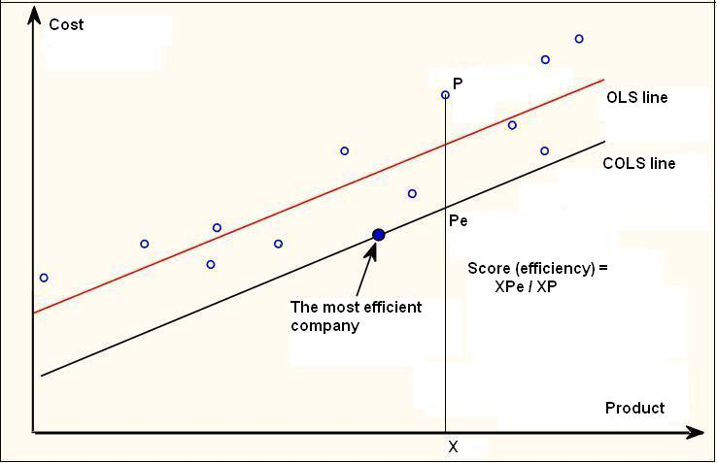
Fig. 2. Regression analysis of costs

In Figure 2, the reference line shows the average cost for each input unit of product - distributed MWh of electricity. Empirical points above the reference line show that these companies incur costs above average for energy that they are distributing and vice versa. The vertical distance between the empirical point of a particular company and corresponding point on the reference line is used as a measure of efficiency.
The method of ordinary least squares is used to determine the reference line, but not the frontier value based on which the most efficient company would be identified against which the relative inefficiency of other companies could be measured. This is achieved by applying of corrected ordinary least square method so as to determine the corrected reference line. Corrected reference line is provided by shifting the reference line in parallel to go through the empirical point that represents the most efficient company. The most efficient company is the company whose empirical point lies below the reference line and the farthest from it. In this way, most commonly, one company is identified, which is located on the corrected reference line and is 100% efficient. This company has the best ratio of costs per unit of electricity distributed, while for the other companies relative inefficiency is calculated on the basis of the distance between the empirical point of a particular company and the corresponding point on the reference line. In Figure 2 the efficiency for the company P is calculated as a ratio of HPe / HP. In this way, the percentage of costs reduction is determined each of the observed distribution companies must achieve in order to distribute electricity at the lowest costs.
In practice, many computer programs - MS Excel, EViews, SPSS, Stata- are used for the assessments of parameters of this model.

Data envelopment analysis (DEA)
Data envelopment analysis is a non parametric method based on linear programming technique that is used for the determination of the frontier (reference) value against which the most efficient company within the observed sample is determined and the relative inefficiency of other companies is measured. This method provides the possibility of a large number of input / output data, and at least three (two input and one output value in the input-oriented model, and two output and one input in the output-oriented model) with the aim of determining the operational efficiency of observed companies. By this method, the company is efficient if no other company in the observed sample is able to produce more (to distribute electric power or to provide more users with services) for a given level of input value (operating expenses), or vice versa incur less of costs for a given level of production - output values.
The operational efficiency of companies depends on two basic elements: technical efficiency, which reflects the ability of a company to achieve maximum production output from a given combination of inputs (labor, capital) and allocative efficiency, which reflects the ability of company to use inputs (labor, capital) in optimal proportions taking into account their relative prices.
Figure 3 presents a theoretical input-oriented model that uses two input values - labor and capital, and one output size - distributed electricity. Horizontal and vertical axis represent input values per unit of product, and the position of distribution companies in the diagram is determined by incurred costs of labor and capital per unit of electricity distributed (point R). Line AA' is a measure of allocative efficiency and shows all possible combinations of labour and capital engaged, taking into account their relative prices. Curve SS' is a measure of technical efficiency, which gives the possibility of achieving the maximum production output for a company for an upfront given (chosen) combination of capital and labor. The position of company in the diagram can only be in the area above or on the maximum technical efficiency curve- SS'. The aim of the model is to determine the relative inefficiency of enterprise by fixing the distance of its current position (point R) in relation to the optimal position of the company in the diagram (point Q') in order to achieve maximum operational efficiency, and to enable optimal usage of limited resources - labor and capital, taking into account their relative prices, with the best possible use of them.

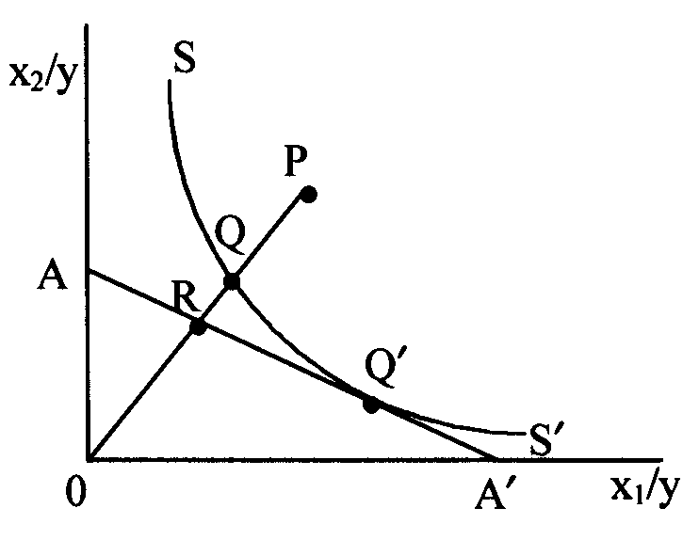
Fig. 3. Input orientated model

Technical inefficiency of company whose position is defined in the point R corresponds to a distance QP, since the point Q has optimal position from the standpoint of technical efficiency of that company. QP matches the amount to which the cost of capital and labor could be reduced, whereby keeping the quantity of distributed electricity unchanged. Thus, technical inefficiency of company TE_{i} corresponds to the OQ/OP ratio.
The company, whose position is in the point Q is technically efficient, but is allocative inefficient due to a non-optimal engagement of inputs - labor and capital. Allocative inefficiency of company AE_{i} lying in the point R corresponds to a distance RQ, and is determined as a ratio OR/OQ.
Overall operational efficiency is the result of achieved technical and allocative efficiency. It is as a product of
TE_{i} * AE_{i}.
Table 2 gives a simple example of the calculation of technical, allocative and operational (in)efficiency of a distribution company lying in the point R. The position of the enterprise in the diagram is determined by incurred costs of labor of 400 mill. din. and of capital of 200 mill. din. for the distributed energy of 10 GWh. Frontier of the technical efficiency (point Q) is determined by cost of labor of 360 mill. din. and cost of capital of 180 mill. din. while the frontier of allocative efficiency (point R) is determined by the optimum proportion of costs of labor of 270 mill. din. and cost of capital of 270 mill. din. for the same level of distributed energy of 10 GWh.
Technical inefficiency of company is 90% in relation to the frontier value and indicates that the company has the potential to proportionally reduce labor and capital cost by 10% for the same volume of electricity distributed. If the company would lie in the point Q, when it would reach the optimal technical efficiency, there would still be scope for it to improve its allocative efficiency, caused by an inadequate engagement of labor and capital, by 5%. Taking into consideration the amount of technical and allocative inefficiency, there is a total potential to improve the operational efficiency by 15%, that is the current operational efficiency of the company by 85%.

 | Work - x₁ | Capital - x₂ | Energy - E
For point P | 400 mil din | 200 mil din | 10 GWh
x₁/E i x₂/E | 40 din/kWh | 20 din/kWh | 10 GWh
unit cost OP | 44,7 din/kWh |  | 10 GWh
For point Q | 360 mil din | 180 mil din | 10 GWh
x₁/E i x₂/E | 36 din/kWh | 18 din/kWh | 10 GWh
unit cost OQ | 40,2 din/kWh |  | 10 GWh
For point R | 270 mil din | 270 mil din | 10 GWh
x₁/E i x₂/E | 27 din/kWh | 27 din/kWh | 10 GWh
j unit cost OR | 38,2 din/kWh |  | 10 GWh
TE_{i} = OQ/OP | 90 %
AE_{i} = OR/OQ | 95 %
EE_{i} = OR/OP | 85 %

Table 2 – Example of calculation of technical, allocative and operational (in)efficiency

These operational efficiency measures assume that the production function of the fully efficient and the best company is known. However, this is not the case in practice, so the frontier value must be estimated via the data envelopment analysis. This involves solving a series of linear problems. For this purpose, various programs are developed based on MS Excel - Solver, EMS and other software packages. The implementation of these programs, based on the selected input and output data, automatically produce a performance rating of analyzed companies.

application of Benchmarking
When applying benchmarking, it is necessary to take into account the size and structure of the observed sample (which consists of companies whose efficiency is analyzed), quality of data (which influence the choice of data to be compared) and the choice of methods that will be used in determining the relative efficiency of companies (it is necessary to respect the basic rule to apply at least two different approaches).
Size and structure of the observed sample and the quality of data are of fundamental importance for the comparative analysis of enterprise efficiency. It is desirable that the sample consists of companies that operate in the same region, which are approximately the same size, operate in a similar legal and economic environment, and the like. The sample should be as large as possible, thus increasing the probability of encompassing efficient companies within the sample. Otherwise, the calculated operational efficiency of mainly non-efficient companies will result in a low level of incentives and will reduce the effects of potential benefits for users of products and services. From our experience, the size of the sample, and the observed number of companies in the sample should be at least twenty. Quality of data used in benchmarking should be high, because, otherwise, the output would be of no importance. Our recommendation is to use published data from official financial reports and information on companies’ business activities.
In regulatory practice, costs of companies are requisite data when conducting a benchmarking exercise. There is the dilemma which type of costs to compare. There are two extremes: to compare total costs (TOTEX), i.e. sum of operating and capital costs, or to compare the individual costs. It is common practice to compare the operating costs (OPEX) reduced by the amount of costs that are not under the direct control of the company management (such as various fees and taxes), while the costs of capital are excluded because of the way they are calculated. Other data included in the benchmarking depend on the type of companies that are compared - whether it is an electricity production, transmission or distribution company. For electricity distribution companies the following data are used: amount of distributed electricity, the number of users connected to the network, number of employees, the length of the network by voltage levels, the length of the network by power line type, the number and size of transformer stations, etc. Commonly a larger number of data is collected, of which some are used to analyze the company efficiency itself, while other are used to verify the accurateness of results obtained. It is important to emphasize that all data requirements need to be met for all the companies in the sample regardless of the chosen benchmarking method. In the event that for one or several companies within the observed sample some of the data are missing (or known, but obviously incorrect), it is necessary to exclude either the data or the company from the analysis.
Table 3 gives an example of benchmarking of 18 distribution companies, with data available on the amount of distributed electricity, number of users connected to distribution network and operational costs. Three benchmarking methods have been applied: a method of partial indicators, corrected ordinary least squares method and data envelopment analysis. In the method of partial indicators, the combined indicator was analyzed, which was calculated by applying the weighted average (weights of 50%) to uni-dimensional indicators: distributed energy / operating costs and the number of users / operating costs. The order of companies was determined by applying the corrected ordinary least squares method on the basis of a simple linear reference line, where the value of operating costs was used as the dependent variable, and the weighted average data on the distributed energy and number of users as the independent variable, with selected weighted factors of 50%. In the data envelopment analysis, operating costs were used as input data, and data on the distributed energy and number of users were used as output data.

Table 3 – Input data

The table below shows for each of the applied benchmarking methods a ranking list established on the basis of relative efficiency of each company from the sample comparing with the most efficient company or in relation to the efficiency frontier which is obtained by applying the appropriate method.

Table 4 – Companies and their efficiency

Fig. 4. – Degree of correlation among methods

The figure shows that results obtained from these three methods have a high degree of correlation – the same companies within a group appear with the best/worst scores. Therefore with great certainty Hun5 and Hun2 can be considered most efficient, and Kyr 2, Lat1 i Alb1 very inefficient.
Very low efficiency of last ranked companies
(which can be negative by applying COSL as a result of theoretical model assumtion) are solved in practice by adopting for any company with efficiency below a certain level, for instance 65%, that frontier as a measurement of its efficiency according to which the incentive X factor can be defined.

CONCLUSIONs
The results obtained from distribution companies’ efficiency benchmarking can be of great importance for both the Regulator and the distribution companies. These can be used as indicators to point out companies’ performance inefficiencies, and, with new regulation methods in place, they will be the basis for the introduction of efficiency incentives into pricing models in Serbia. Implementation of these regulation methods will enhance the operational (technical and allocative) efficiency of companies, resulting in lower prices for distribution service users, as well as in more opportunities for the companies to earn profit by efficiency improvements.
In practice, in order to obtain results of high quality, it is necessary to use at least two different methodologies, compare total operational costs, take account of the sample size encompassing not less than 20 companies and verify the fit-for-purpose choice of companies. This, however, opens up a question how to conduct a benchmarking in Serbia if there are only 5 electricity distribution companies. One possibility is to use an “international” benchmarking, publicly available and published data from official financial reports and business information of distribution companies in European countries, or to administer data of Serbian electricity distribution companies by branches for the purpose of providing a satisfying sample size.
This paper describes different techniques in theory and their application in practice, which can be used for benchmarking distribution companies – method of partial indicators, corrected ordinary least squares method and data envelopment analysis. These are illustrated in an example comprising 18 distribution companies. The obtained results have shown a high degree of correlation and as such can provide a reliable basis for the determination of the incentive X factor for each distribution company.
There is no consensus amongst regulators as to which methodological approach is best and which to use for setting incentive factors. Common in practice are results obtained in DEA. Results obtained by applying partial indicator or corrected ordinary least squares methods are used for the analysis of given indicators.

References
Books:
- Žižić M, Lovrić M, Pavličić D, „Metode statističke analize“, 1991, Univerzitet u Beogradu, Ekonomski fakultet
- Ajodhia V, „Regulation beyond price“, 2005, Delft University of technology, Delft

Papers Presented at Conferences (Unpublished):
- Ajodhia V, Petrov K, Scarsi G, „Integrated cost and quality benchmarking in electricity distribution“, 2004, 6th IAEE European Conference: Modelling in Energy Economics and Policy, Zurich
Technical Reports:
- KEMA, „Distribution Benchmarking – Activities for Electricity and Gas“, 2008, Report, Project - Technical Assistance to the Energy Agency of the Republic of Serbia, Beograd

Biography
Nebojša Despotović was born in Belgrade, in 1972. He graduated from the University of Belgrade, Economics Department in 1997. In the period from 1998 to 2006 he worked in the company Electric Power Utility of Serbia (EPS), Economic-Finance Department. 1998-2003 he worked as a financial analysts and leading economists carrying out duties associated with financial planning, analysis and control, creation and implementation of transfer price systems and tariff system analysis of EPS. In the period 2004-2005 he instructed managers on the project called “Development of Managers of the Future”. Since 2006 he has been employed at the Energy Agency of the Republic of Serbia, holding the position of the Senior Economics and Finance Expert.
Aca Vučković was born in Belgrade in 1961. He graduated and received his M.Sc. degree in electrical engineering from the University of Belgrade. From 1989 to 2005 he worked in the Electric Power Utility of Serbia, where carrying out duties associated with all aspects of power system operations planning, calculation of losses in transmission and distribution networks, load forecasting and tariff system analysis of EPS. Since 2005 he has been employed at the Energy Agency of the Republic of Serbia, holding the position of the Senior Expert for Electricity. His present research interests are all aspects of tariff policy, renewable energy sources and energy efficiency.

Terazije 5/V, 11000 Belgrade, tel: 011 3037183, fax: 011 3225780, email: nebojsa.despotovic@aers.rs

